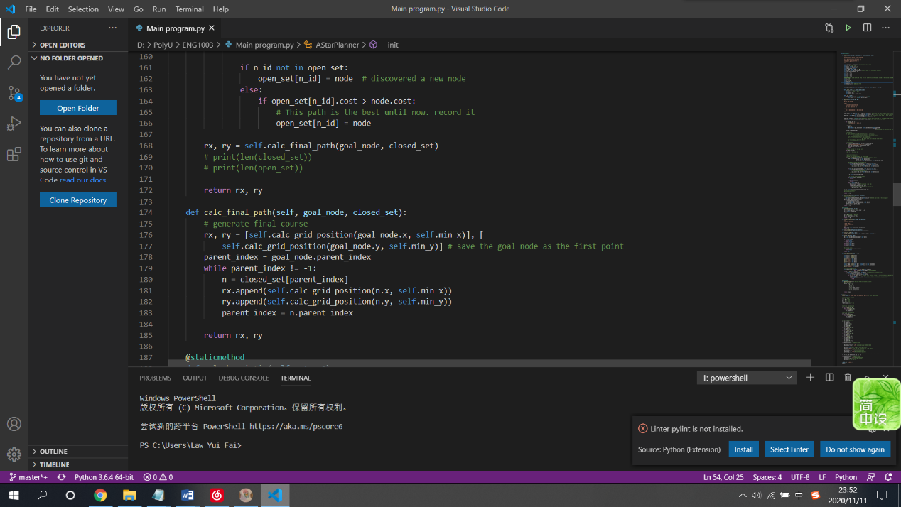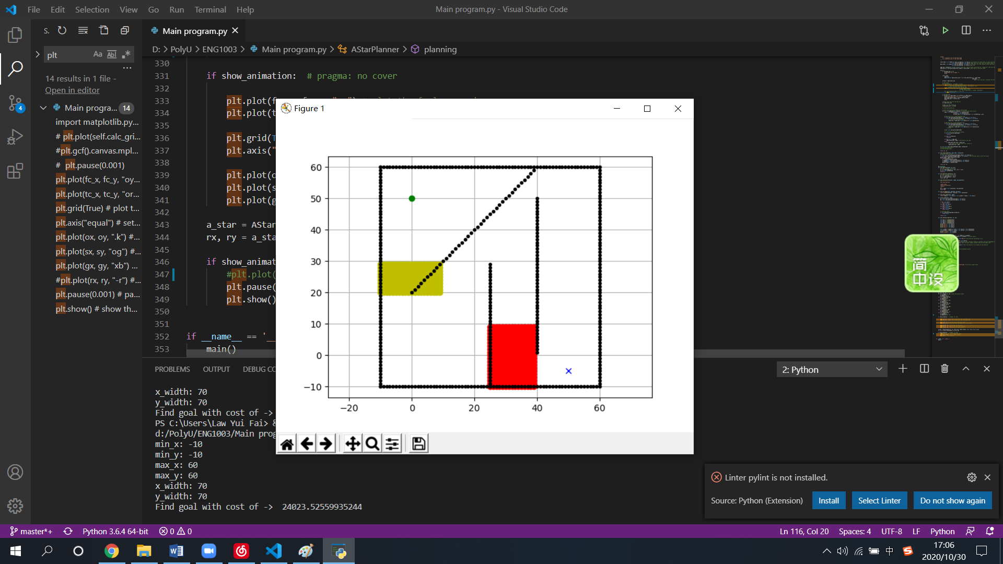

Present by

Bangyan FU

Ho Lam LAW

Yui Fai LAW

Chenyu WANG

Man Nok WONG

ENG1003 Freshman Seminar for Engineering Project (AAE)

Group 3

Report

* Please design cover page yourself.
* Times New Roman, 12pt, Single-space spacing
* No less than 15 pages and no more than 30 pages

1. Background of Path Planning to Aviation Engineering

Air transport is said to be the safest mode of transportation in the 21 century, the accident rate was just 1.35 per 1 million flights [1]. Apart from improved regulations and safety practices, the advanced path planning technique has also guarded the safety of air transport.

In short, Path planning is the planning on the route for flights, regarding weather, fuel consumption, and airspace.

A path plan includes the fuel onboard and the route will be followed that gives the safest and the most efficient flight. For example, the flight path will avoid a tropical cyclone that may threaten aircraft safety. It also complies with Air Traffic Control requirements [2]. For instance, the flight path will divert from restricted military airspace and maintain a required clearance level from the residence when departing or arriving.

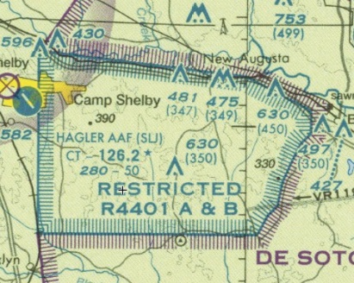 Restricted Airspace on an Aviation Chart [3]

Flightpath will be planned prior to each flight. However, operation practice varies.

In General Aviation, pilot flying will plan and write the flight path on a flight plan sheet with a navigation plotter and aviation chart including the bearing of waypoints, lowest safe altitude, distance, and even contingency destinations for each waypoint. During inflight, the pilot will follow the flight path with the aid of navigation instruments such as the VOR and heading indicator.

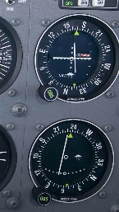 VOR on a light aircraft[4] 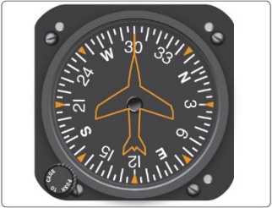Heading indicator [5]

In Commercial flight or aircraft equipped with the Flight Management System, a flight plan will be done by the dispatcher as planning a commercial flight is much more complicated as many more parameters are taken into account. The flight plan is then sent to the FMS and the pilot will enter the grid provided manually to double-check.

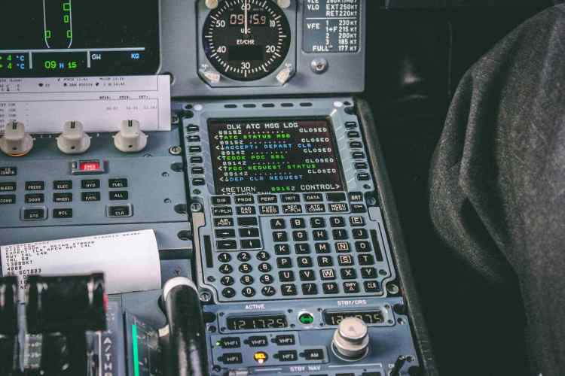A Flight Management System on commercial Jet[6]

After takeoff, the FMS will show the planned flight parameters such as heading and speed required, pilot can set the aircraft manually to follow the flight plan or handover to the AutoPilot system.

It should be noted that flight path can be changed even in flight due to traffic or rapidly changing weather, where the aircraft has to deviate, while safety is still the first and utmost important factor.

1. Theory of Path Planning Algorithm

**Path Planning** is also known as motion planning, this term is used in the digital, aviation world, people often use this term to express the idea to instruct, inputting command to the robot or computer to go from point A to point B with the fewest cost. In our project, we are instructed to achieve several path planning tasks by using the A* Path Planning Algorithm. Yet, what is A star algorithm?

**A* Algorithm**

A* algorithm is first published in 1968 by Peter Hart, Nils Nilsson and Bertram Raphae, which is formulated in terms of vectors weighted graph[7]. A star algorithm can be expressed by the following formula.[8]

***f(n)=g(n)+h(n)***

n=next node on the path

f(n)= total cost of the path

g(n)=cost of the path from the start node to n

h(n)=estimates the cost of the cheapest path from n to the goal using heuristic function

**Heuristic algorithm**

A major component of A star algorithm is a heuristic function applied. To simplify the concept of Heuristic will need a picture to aid.

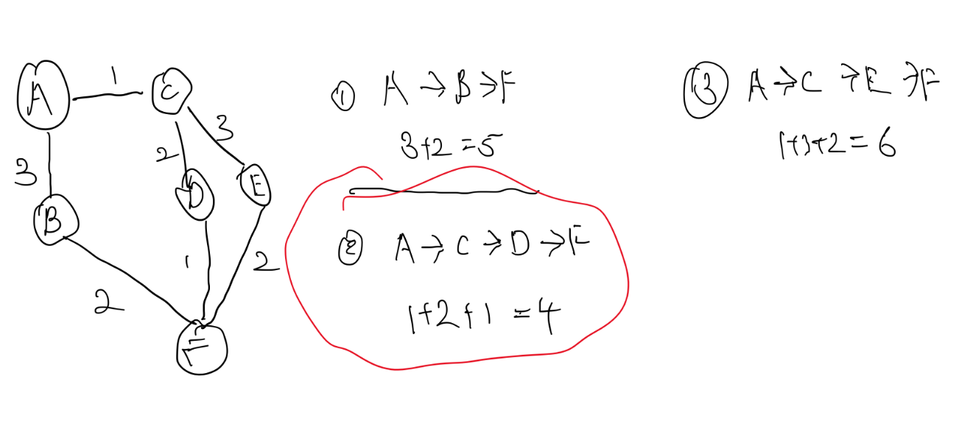

The goal of the above picture is going from point A to B with the lowest cost, where we can see each path have the respective cost. By using heuristic algorithm, we will search for all the possible routes where we can see three separate ways and find the lowest cost. Which we can see method 2 is the cheapest way to achieve the goal.

In this project, we have several obstacles, first the wall that cannot be touched.

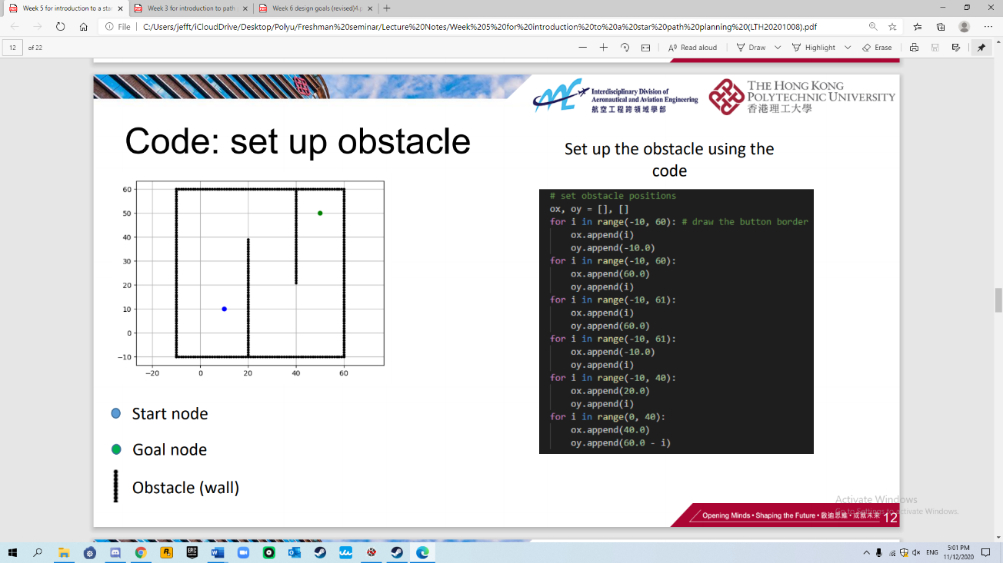We set up walls using code to represent the restricted area that are not allowed our flight to touch.

Second, the cost of the trip.

C = 𝐶f ∙ ∆𝐹 + 𝐶𝑇 ∙ ∆𝑇 + 𝐶c

𝐶𝐹=Cost of fuel per kg

𝐶𝑇=Time related cost per minute of flight

𝐶𝑐=Fixed cost independent of time

𝐶𝑇=Time related cost per minute of flight

∆𝐹=Trip fuel

∆𝑇=Trip time

We are also required to implement different costs to simulate reality.

Third, additional cost area

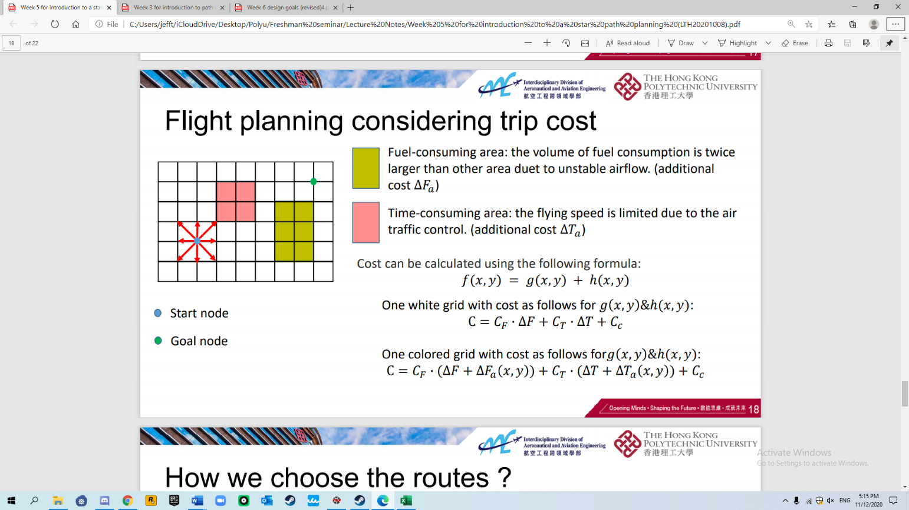Although there are area that may have additional costs, yet, it may still worth traveling through this area.

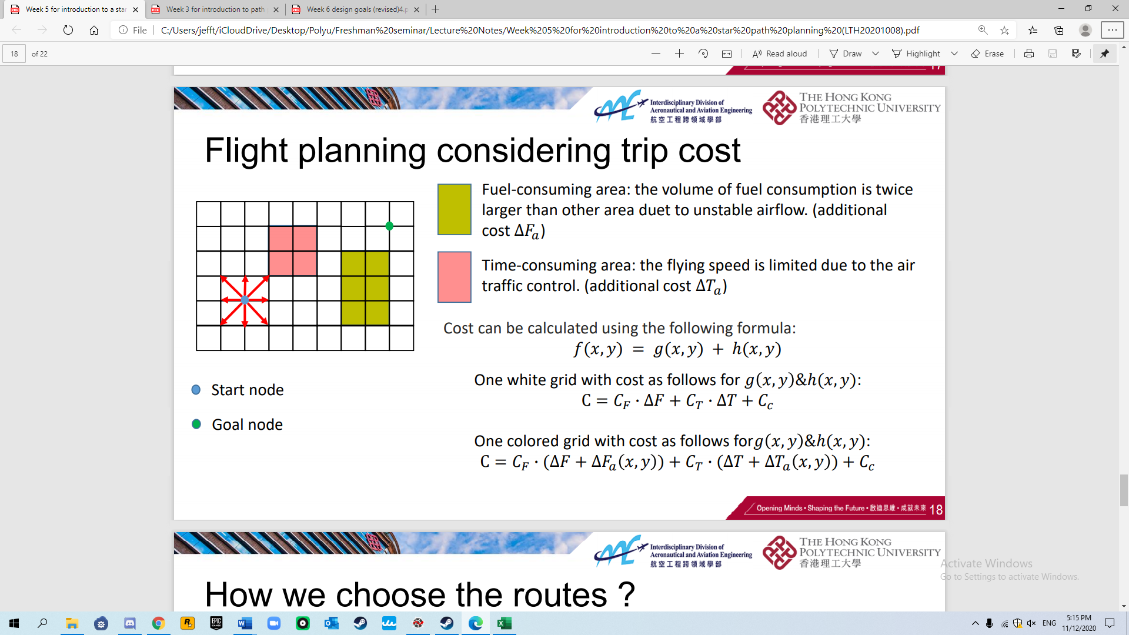

1. Introduction of the Engineering Tools
   1. Python

Python is a cross-platform computer language, a high-level scripting language that combines interpretation, complication, interactivity and object-oriented programming. This application was originally designed for writing automation scripts (shell). With the non-stop updates of version and expansion of new functions of computer language, Python gets more and more popular with the development of an individual and huge project.

It is obvious that the number of aircraft is quite large compared with the last century, which makes the possibility of aircraft crash increase. Such as the famous disaster Überlingen mid-air collision. Because of a slight fault made by the air traffic controller, the crew and all passengers of two planes died in this accident. One year ago, we lost a famous formal NBA star, Kobe Bryant. His pilot could not handle the extreme climate himself.

I think all these tragedies told us that we can ask the computer for help. We can use python to do Path planning, which is a computational problem to find a sequence of valid configurations that moves the object from the source to destination. The term is used in aviation.

Also, there are many complex factories may affect the airplane but it can be very hard for human to remember all the environmental conditions such as temperature, the density and flow velocity. But if we use python, we can write a code and ask computers to analyze all the features.

In our AAE project, we use Python to run our code downloaded from Git Hub. It can help us find the min-cost or the greatest voyage path. After we are more familiar with Python, we try to modify the code to meet our own needs in task 2 and 3.

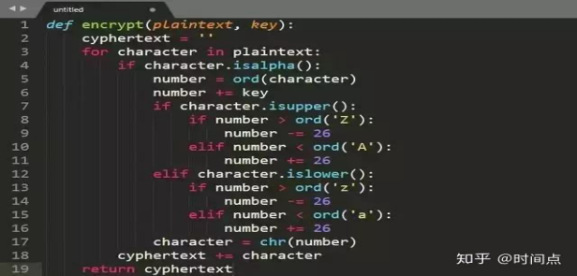

* 1. GitHub



GitHub is a Software source code hosting service platform established in 2008. Programmers and engineers can sign in accounts to create code repositories for their coding. For programmers, GitHub is like their special social media, they are able to share codes or develop software together. GitHub has become the largest code storage site and open source community.

When using GitHub, users can access and operate projects with the standard Git command, and the projects can be downloaded in the format of ZIP.

In our AAE project, GitHub played a significant role in group collaboration. We firstly created a GitHub repository so that we could share codes and messages. When finished tasks on Python, group members would upload the code on GitHub so that other members could make use of them. What’s more, the teaching assistant also joined in the repository so that he could assess in time.

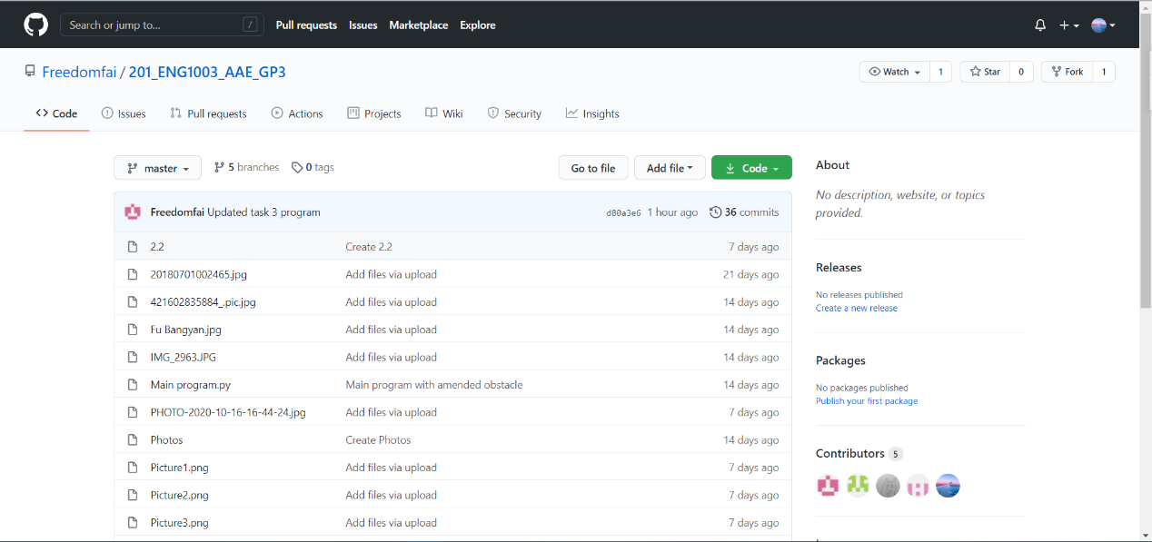(The group GitHub repository)

In general, GitHub is particularly essential for our engineering students not only in this project but also in future works.

1. Task 1: Methodology, Results and Discussion
   1. Methodology

Step 1: Define the position of starting the goal.

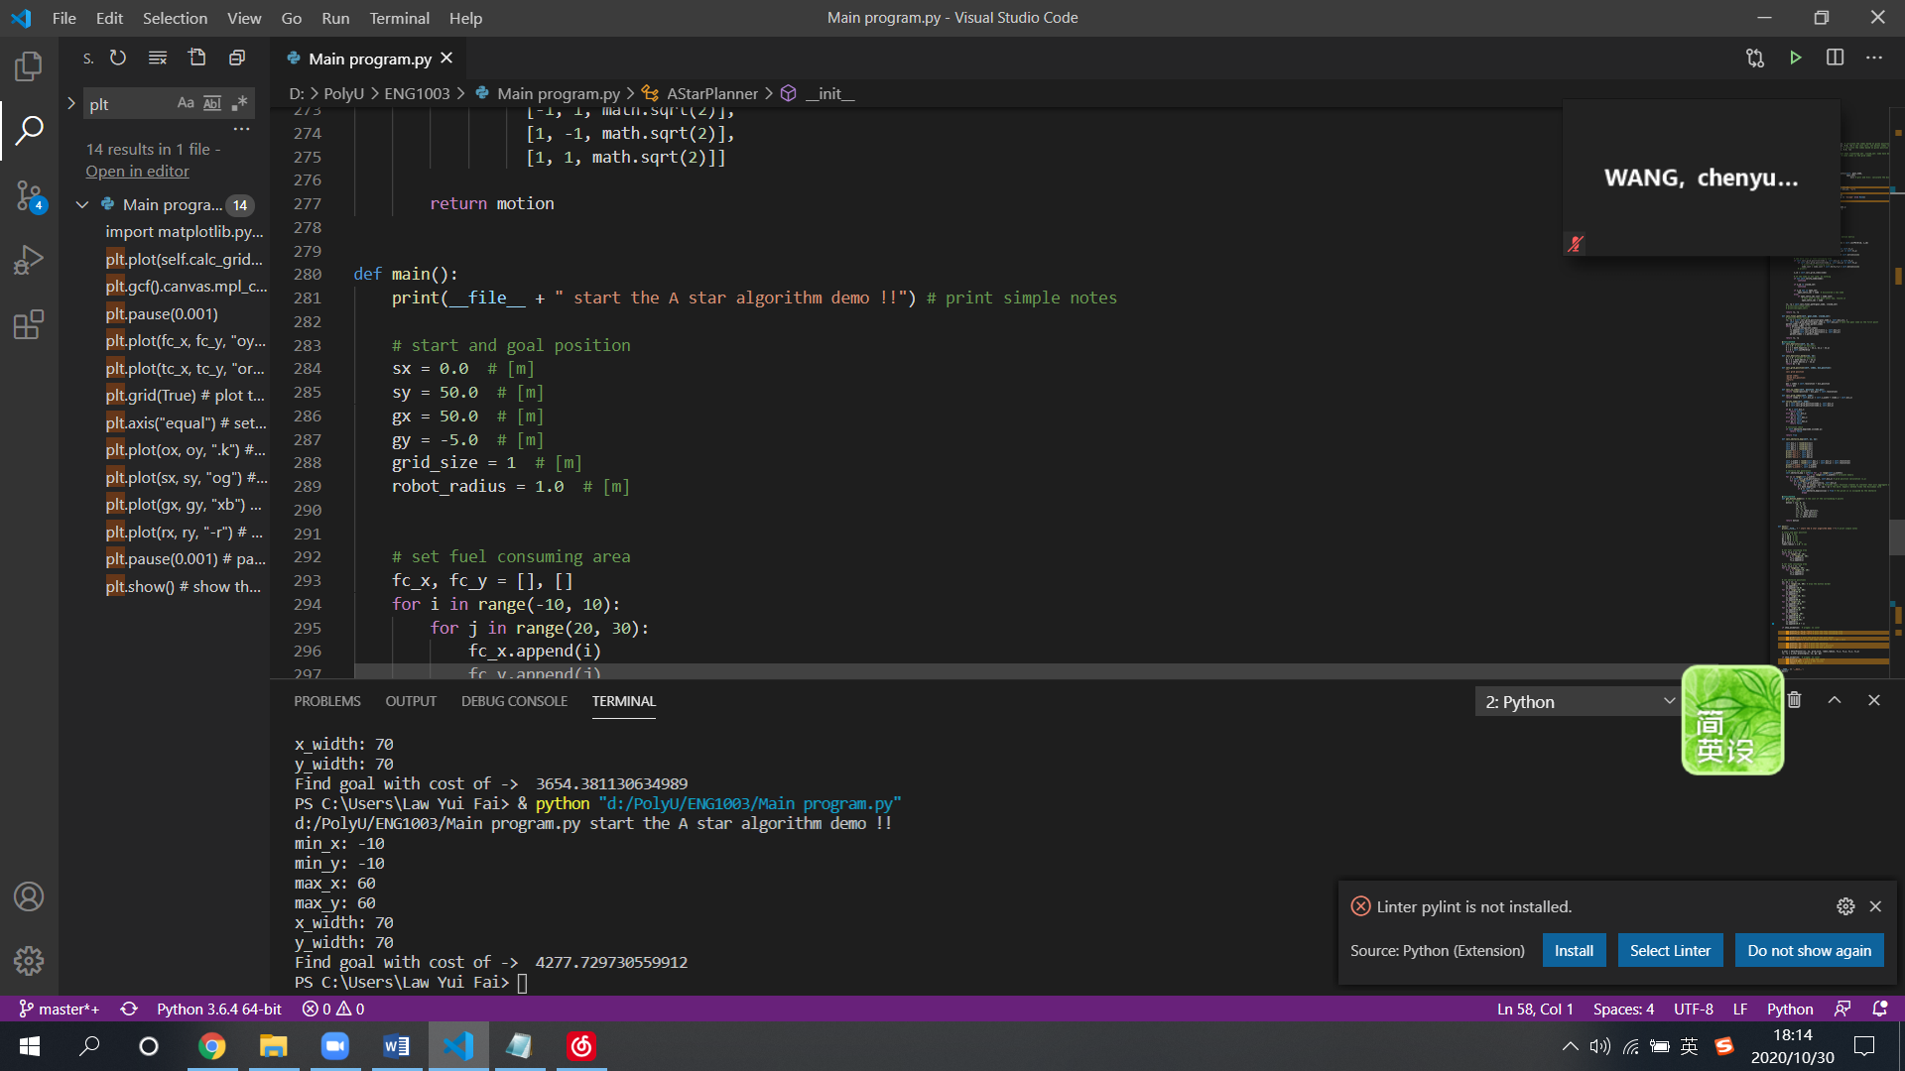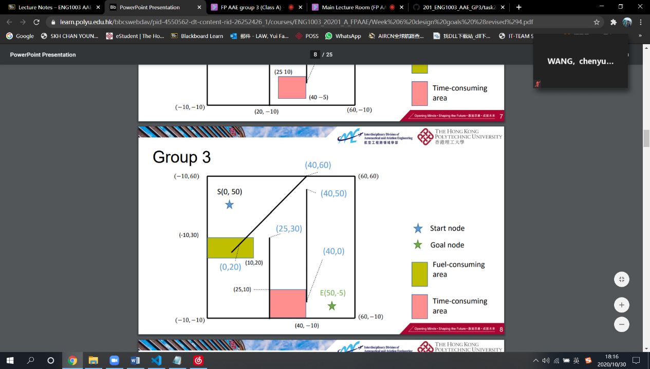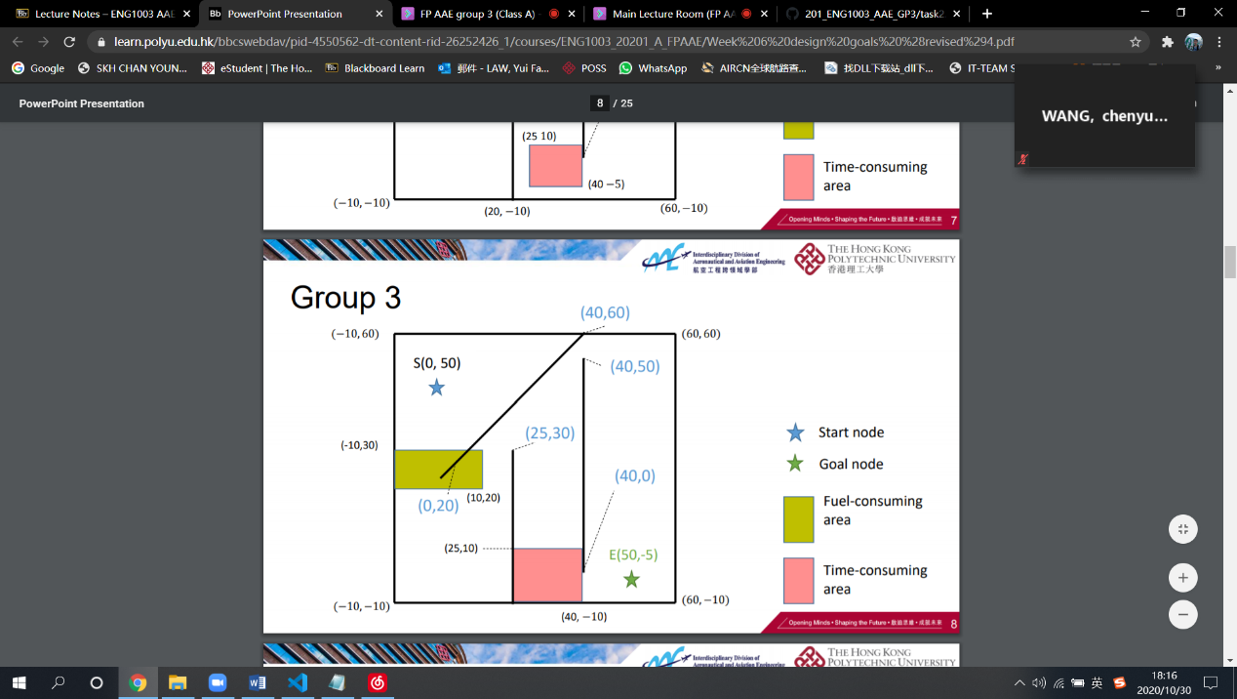

In the beginning, we amended the position of the starting point and the goal point according to the slides. The “sx” variable indicates the x-coordinate of the starting point and the “sy” variable indicates the y-coordinate of the starting point. On the other hand, “gx” and “gy” indicate the x-coordinate and the y-coordinate of the goal point respectively.

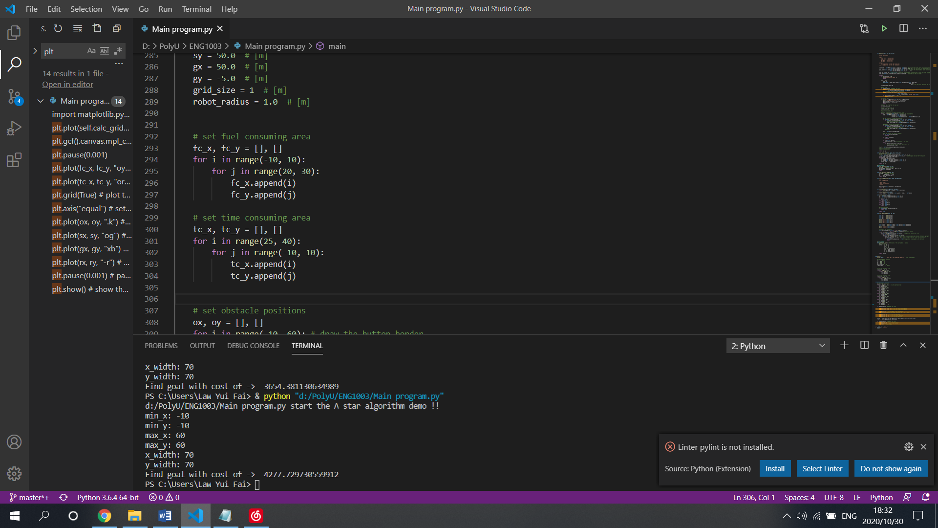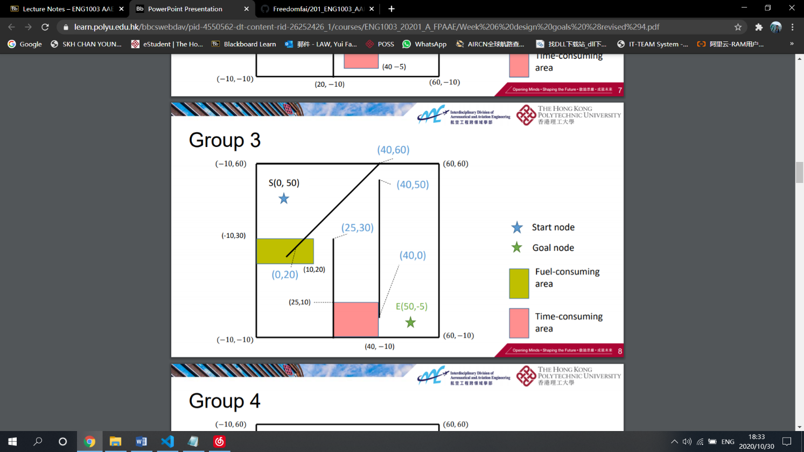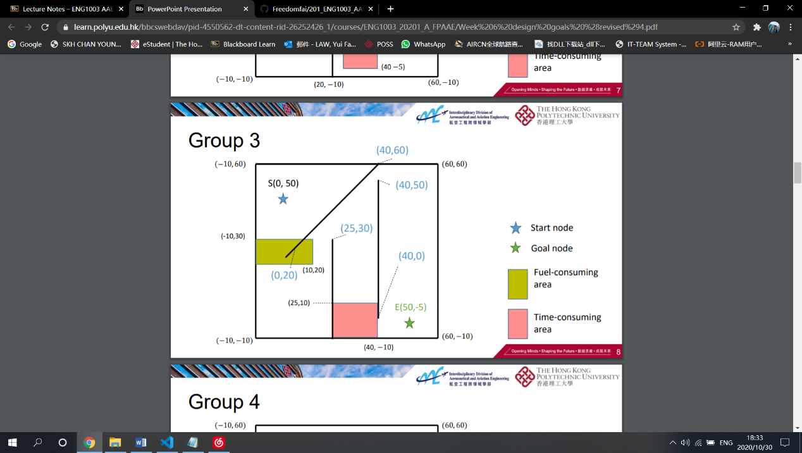

Step 2: Define the additional area

Next, we amended the fuel consuming area (Yellow area) and the time consuming area (Pink area).

Step 3: Define obstacles.

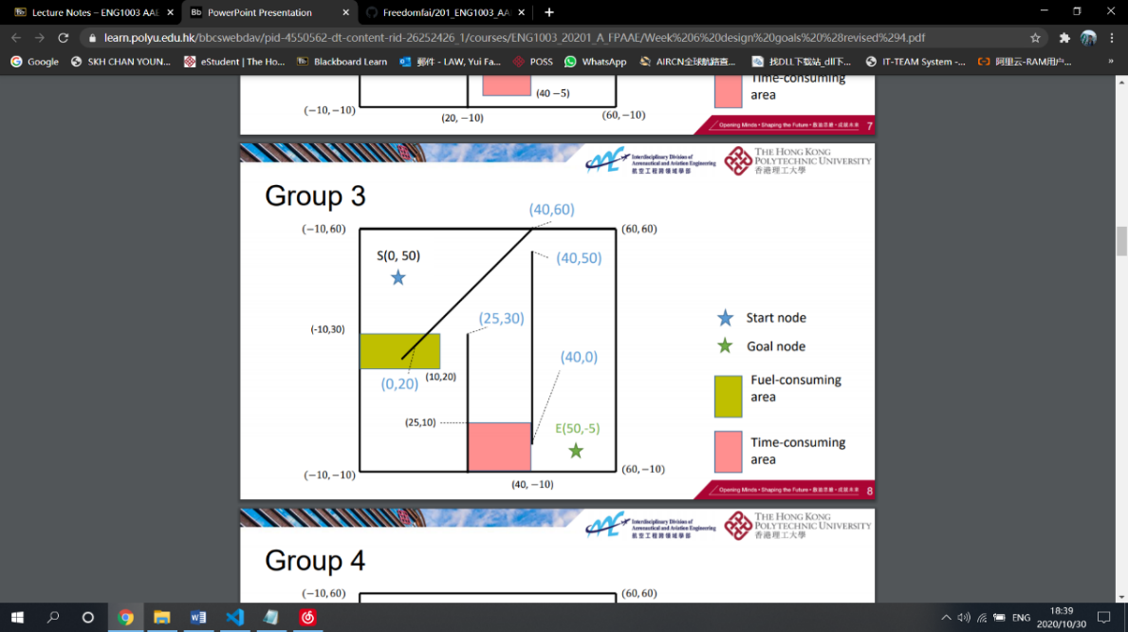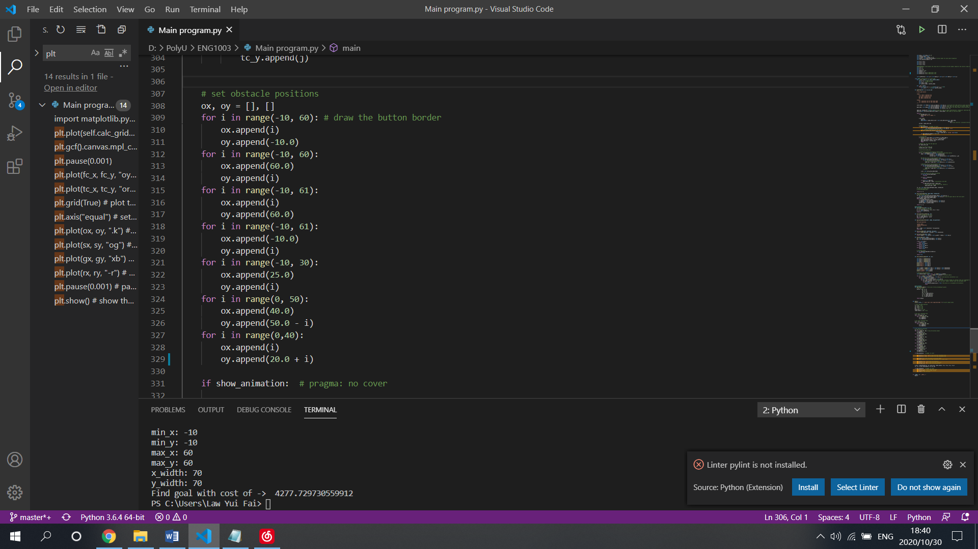

Including the border, we amended the obstacles with one slant obstacle and two vertical obstacles.

After amending the starting, goal, fuel and time additional area, and the obstacles, the figure will be like:



|  |  |  |  |  |  |  |  |
| --- | --- | --- | --- | --- | --- | --- | --- |
| Aircraft Model | 𝐶f | ∆F | 𝐶T | ∆T | CC | ∆𝐹a | ∆𝑇a |
| PolyU-A380 | 1 | 1 | 2 | 5 | 10 | 0.2 | 0.2 |
| PolyU-A381 | 1 | 1.5 | 3 | 5 | 10 | 0.3 | 0.4 |
| PolyU-A382 | 1 | 2.0 | 4 | 5 | 10 | 0.4 | 0.5 |
| PolyU-A383 | 1 | 2.5 | 5 | 5 | 10 | 0.5 | 0.1 |

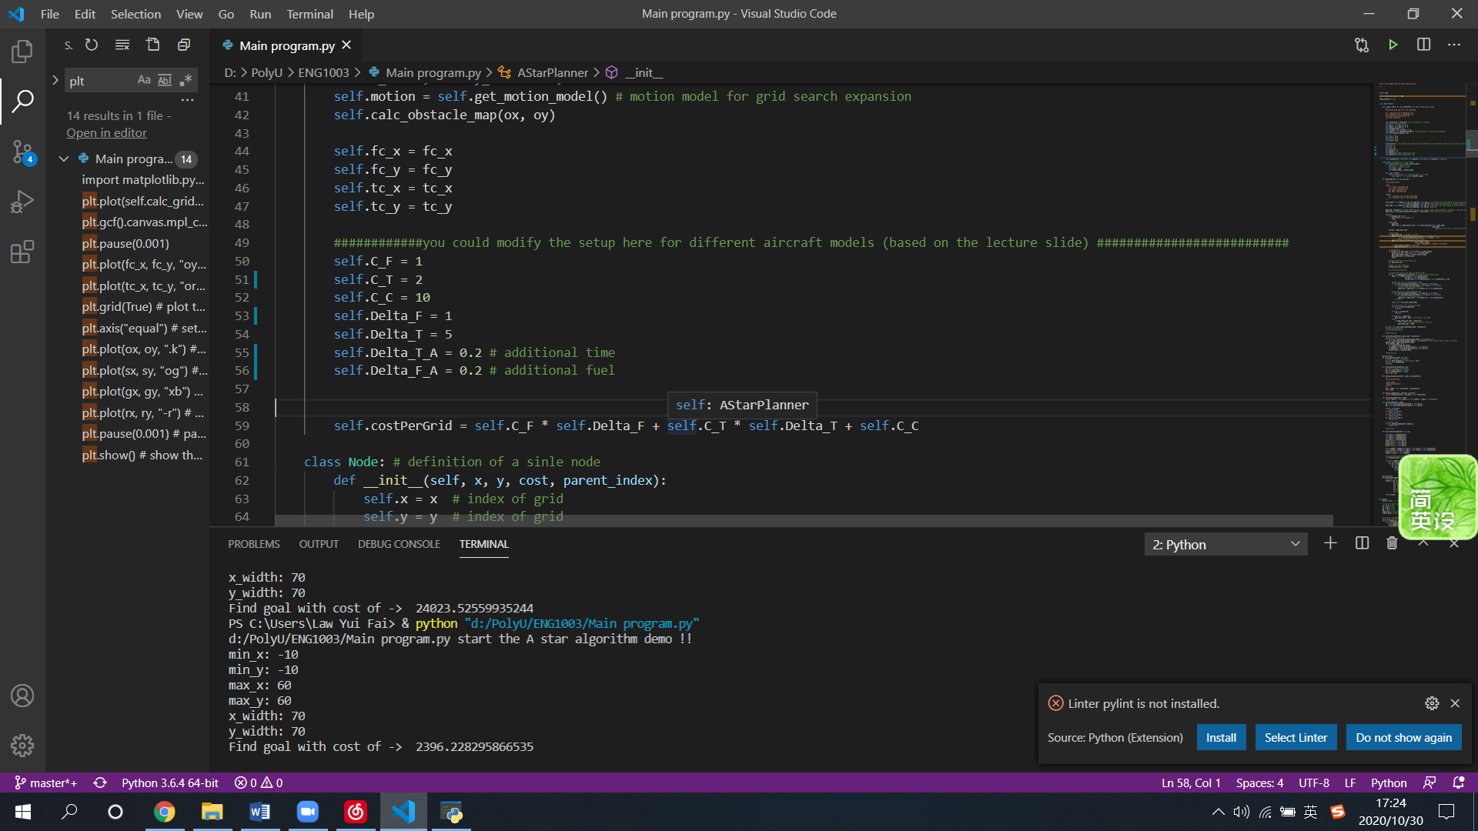According to the given table available in the lecture slides, we amended the setup for different aircraft models in the program one by one.

* 1. Result

The following figures show the minimum cost after computed by the program with their routes.

|  |  |
| --- | --- |
| PolyU-A381 | 3025.825423928881 |

|  |  |
| --- | --- |
| PolyU-A380 | 2396.228295866535 |

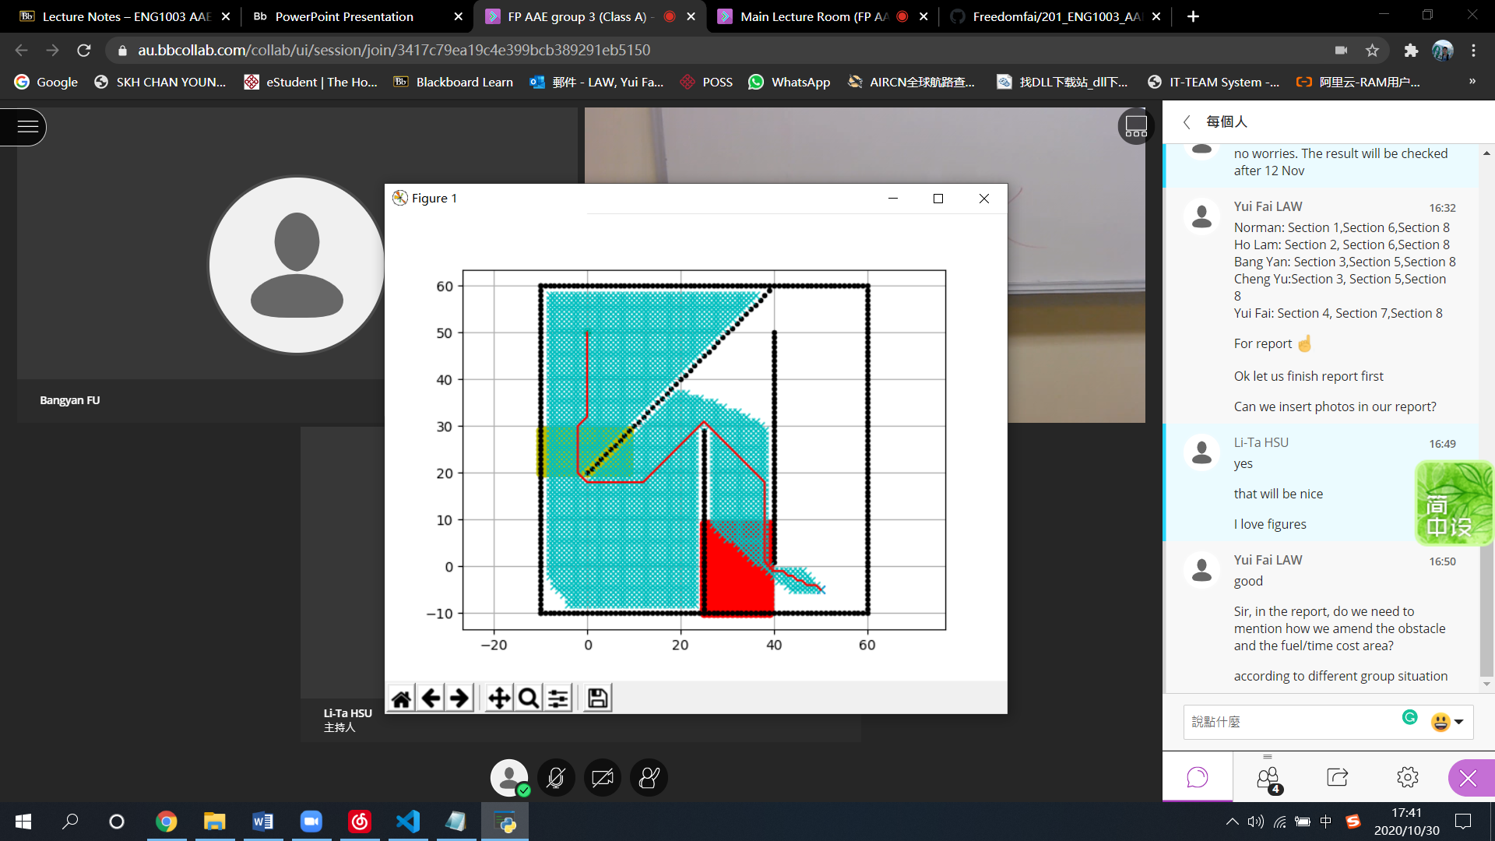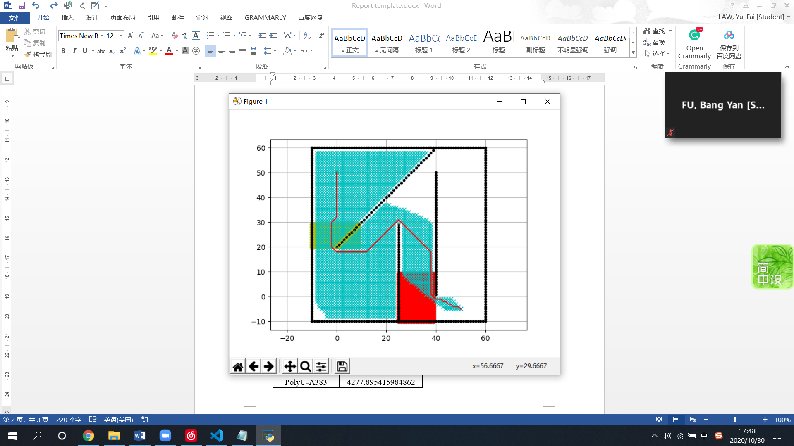

|  |  |
| --- | --- |
| PolyU-A382 | 3654.381130634989 |

|  |  |
| --- | --- |
| PolyU-A383 | 4277.729730559912 |

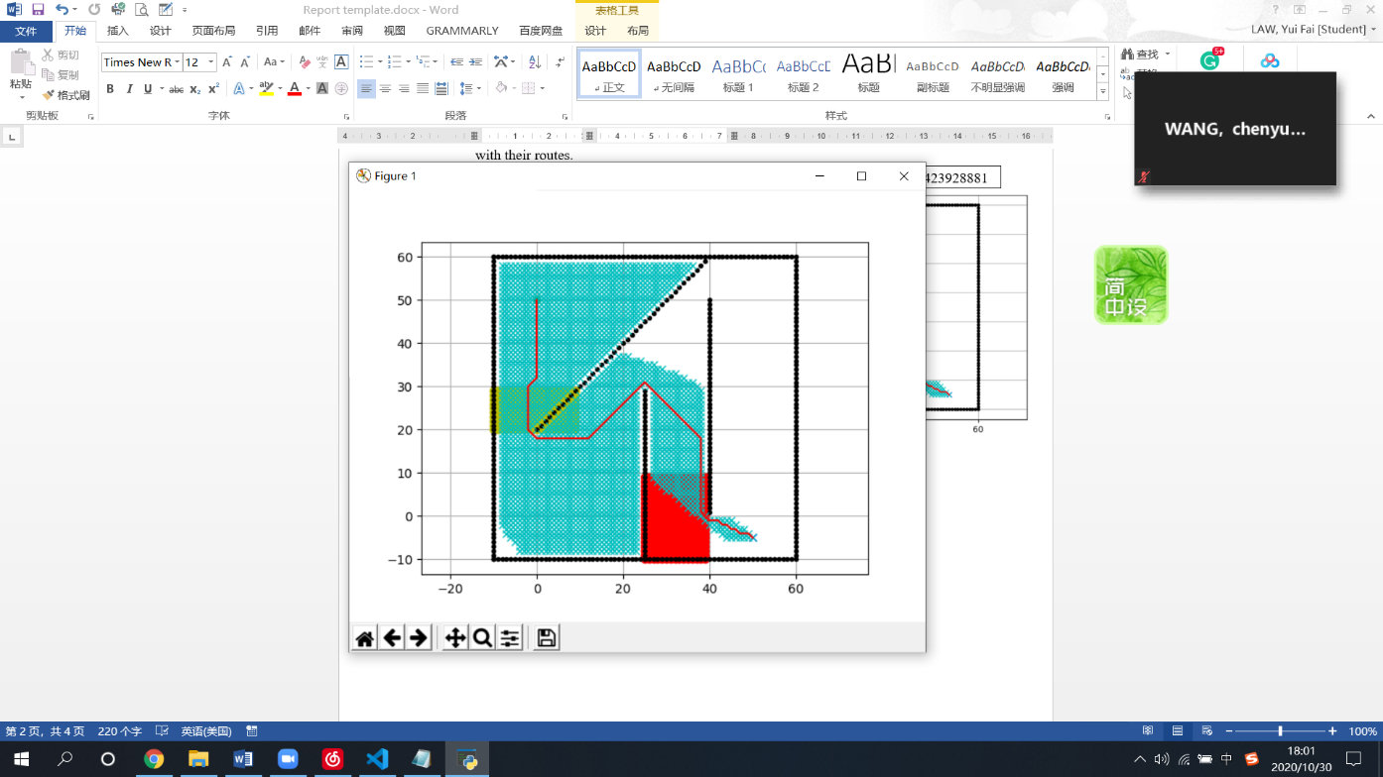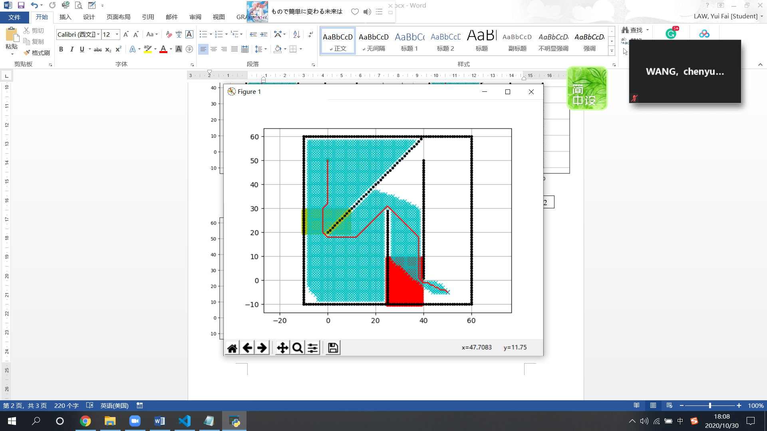

* 1. Discussion

After the calculation by the program, the PolyU-A380 model achieved the minimum cost in group 3 challenge with the cost of 2396.228295866535. The routes of the 4 models are seemed to be the same.

1. Task 2.1: Methodology, Results and Discussion
   1. Methodology

After getting familiar with A Star Path Planning, in task 2.1, we are required to design a new aircraft model using the given obstacles. The new aircraft model contains several parameters, we need to calculate the two variable parameters that refer to the constant values and constraints to minimize the flight cost.

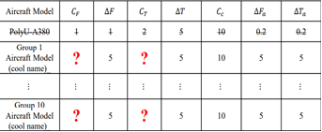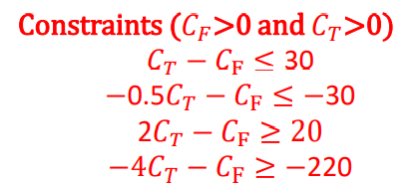

Firstly, we need to use the code upload by Dr. Wen. Because we still need it to calculate the total cost, what we need to do is to input the figures of Cf and Ct.

Secondly, we used my math knowledge to find the domain of Cf and Ct, after doing linear programming, we managed to solve these inequation sets.

* 1. Results

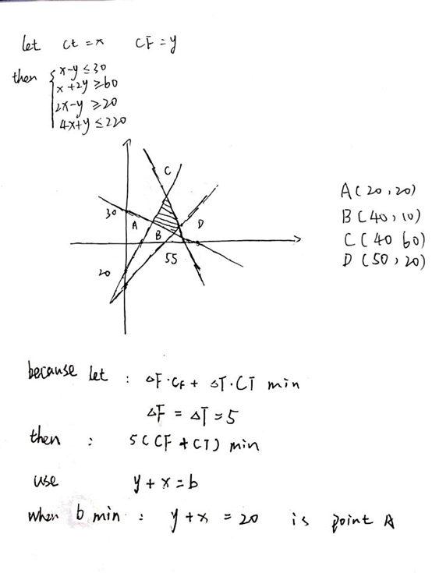

At last, we find a quadrilateral of the possible domain of these two variables with the lowest cost.

1.Ct=20 Cf=20

2.Ct=40 Cf=10

3.Ct=40 Cf=60

4.Ct=50 Cf=20

After we inputted these parameters to the main program, we obtained these outputs:

1.24023.52559935244

2.29719.110011624045

3.58197.03207298188

4.41110.278836167134

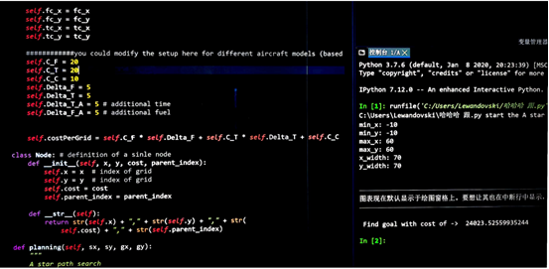

* 1. Discussion

From the above results, we concluded that the lowest cost is 24023.52559935244 units with the variables Ct=20 Cf=20.

1. Task 2.2: Methodology, Results and Discussion
   1. Methodology

There are 4 constraints and 6 variables in task 2.2 which are

𝐶𝐹∆𝐹 + 𝐶𝑇∆T ≥ 25

𝐶𝐹 + 𝐶T ≥ 10

∆𝐹 + ∆T ≥ 10

∆𝐹𝑎 + ∆𝑇𝑎 ≥ 10

Step 1: Find the variable of Cf, Df, Ct, Dt by the first 3 constraint

We computed the first 3 constraints by letting 𝐶𝐹, 𝐶T, ∆𝐹, ∆T as a set of numbers by trial and error method. As we are finding the lowest cost, the variables should be as small as possible.

Step 2: Find the variable Dta and Dfa

There are nine sets of solutions, with the combinations of ∆𝐹𝑎 +∆𝑇𝑎=10 (i.e. ∆𝐹𝑎=9 while ∆𝑇𝑎=1, ∆𝐹𝑎=8 while ∆𝑇𝑎=2, etc.). We substitute the 4 variables found in step 1 and the combinations to the main program to find the lowest cost.

By combining these two values, we found the smallest value we need for the flight.

* 1. Results

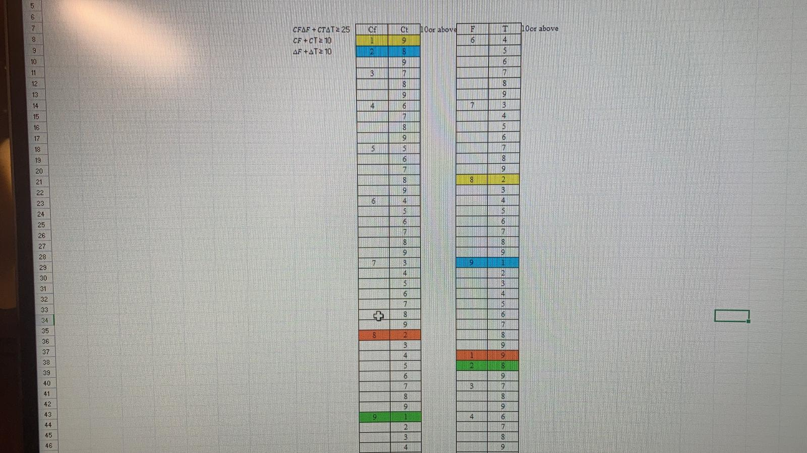

The results of step 1:

The results came up with 4 sets of the solution of the 4 variables, which are the lowest values in the first constraint.

(𝐶𝐹∆𝐹 + 𝐶𝑇∆T ≥ 25)

Set 1

Cf=1 Df=8 Ct=9 Dt=2

Set 2

Cf=9 Df=2 Ct=1 Dt=8

Set 3

Cf=2 Df=9 Ct=8 Dt=1

Set 4

Cf=8 Df=1 Ct=2 Dt=9

Both sets of values give a cost of 26 in the first constraint.

C = 𝐶𝐹 ∙ ∆𝐹 + 𝐶𝑇 ∙ ∆𝑇 + 𝐶c

According to the above equation, the cost of these 4 sets should be the same. To test with our assumption, we input the 4 sets of values with constants of C_c=10, ∆𝑇𝑎 =1, ∆𝐹𝑎 =9. Both 4 sets of values give a cost of 4201.234990397903. The variables Cf, ∆𝐹, Ct, ∆𝐹𝑎 **might be** independent of ∆𝑇𝑎 and ∆𝐹𝑎.

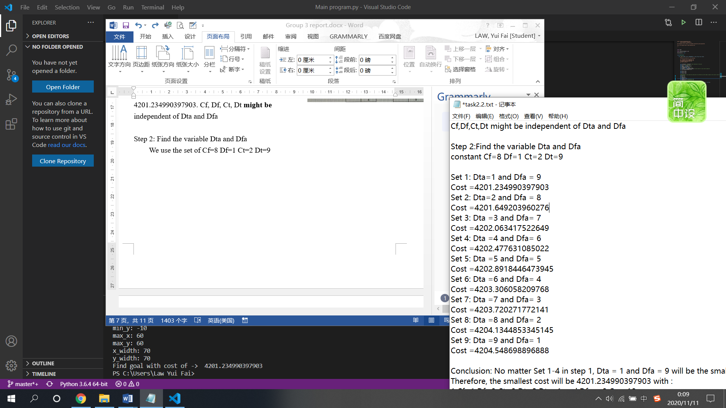The results of step 2:

Next, we calculated the values of ∆𝐹𝑎 and ∆𝑇𝑎. By combining these two values with using the result (set 1, Cf=1 Df=8 Ct=9 Dt=2), we found the smallest value we need for the flight.

Answers vary from Cost =4204.548698896888 to Cost =4201.234990397903 when ∆𝑇𝑎=9 and ∆𝐹𝑎=1 to ∆𝑇𝑎=1 and ∆𝐹𝑎=9.

* 1. Discussion

No matter Set 1-4 in step 1, Dta = 1 and Dfa = 9 will be the smallest cost with the value of 4201.234990397903

Therefore, the lowest cost will be 4201.234990397903 with :

1.Cf=1 Df=8 Ct=9 Dt=2 Dta=1 and Dfa = 9 C_c=10

2.Cf=9 Df=2 Ct=1 Dt=8 Dta=1 and Dfa = 9 C_c=10

3.Cf=2 Df=9 Ct=8 Dt=1 Dta=1 and Dfa = 9 C_c=10

4.Cf=8 Df=1 Ct=2 Dt=9 Dta=1 and Dfa = 9 C_c=10

1. Task 3: Methodology, Results and Discussion
   1. Methodology

|  |  |  |  |  |  |  |  |  |  |
| --- | --- | --- | --- | --- | --- | --- | --- | --- | --- |
| Aircraft Model | 𝐶f | ∆F | 𝐶T | ∆T | CC | ∆𝐹a | ∆𝑇a | CP | ∆P |
| PolyU-A380 | 1 | 1 | 2 | 5 | 10 | 0.2 | 0.2 | -2 | 2 |

According to the instruction, the PolyU-A380 model is used for task 3.

|  |  |
| --- | --- |
| PolyU-A380 | 2396.228295866535 |

Step 1: Define the area

From the result of task 1, the route of the model is shown on the right-hand side. As the maximum size of the minus-cost area is 16m2, we decided to assign the minus-cost area which area is 1x16 m2 as shown in the figure. If the aircraft flies through the area, the cost of the trip will be reduced by 64 units as the plane pass through all the 16 m2 area.



(1,49)

(0,49)

(0,33)

(1,33)

Step 2: Implement into python

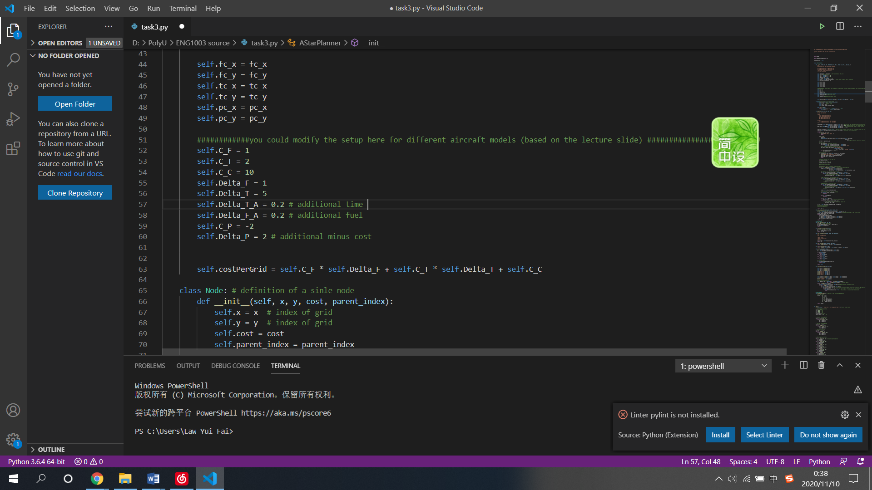

We define the variable pc_x and pc_y as the x and y coordinates of the area respectively.

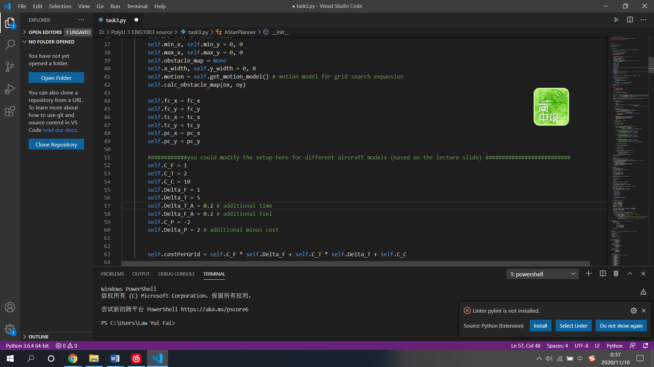

After that, we define the constant C_P and Delta_P with the value specified in the lecture notes, which is Cp = -2 and Delta P = 2.

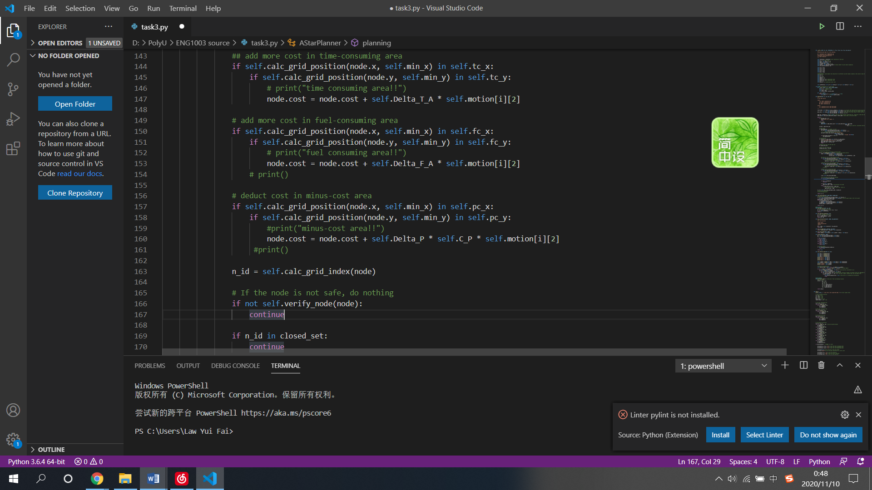

After defining the necessary variables, we add the minus-cost area module below the module of adding cost in fuel-consuming area to calculate the deducted cost in minus-cost area.

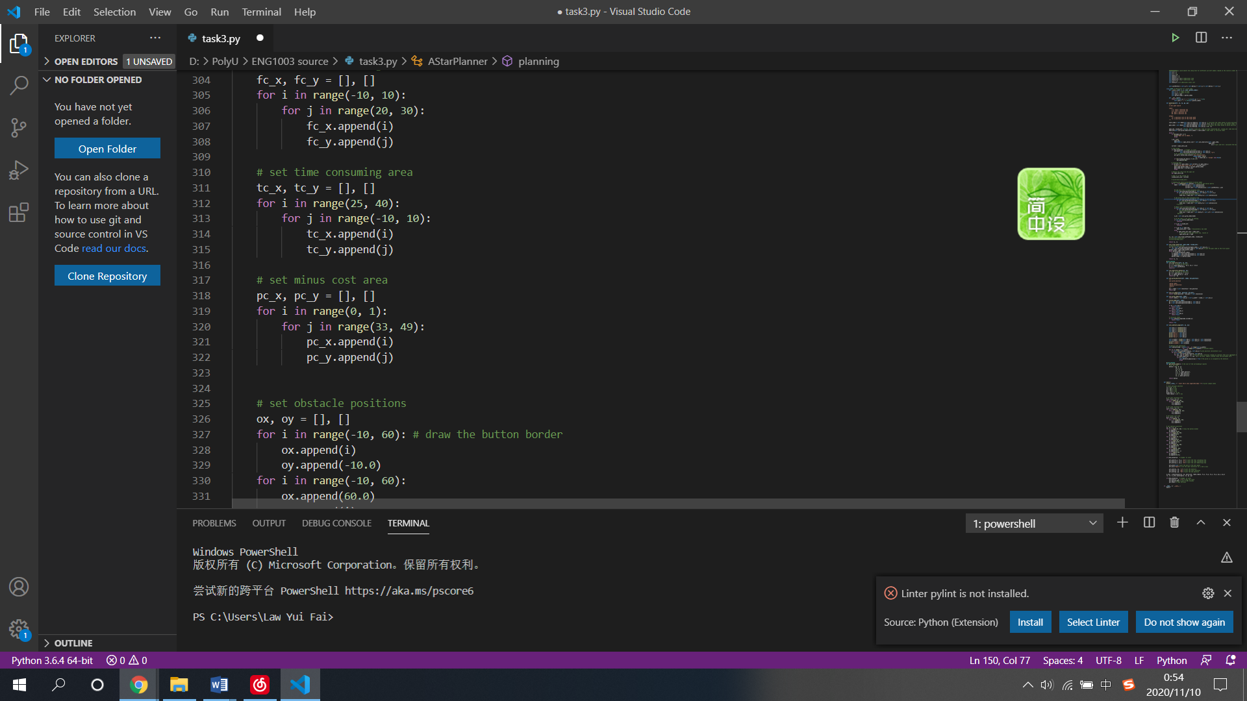

According to our plan in step 1, we set the minus cost area in the python file. To improve the user interface of the program, we plot the minus-cost area on the graph (see below) which will be shown after the program found the best routes with the lowest cost. The area will be blue in color.

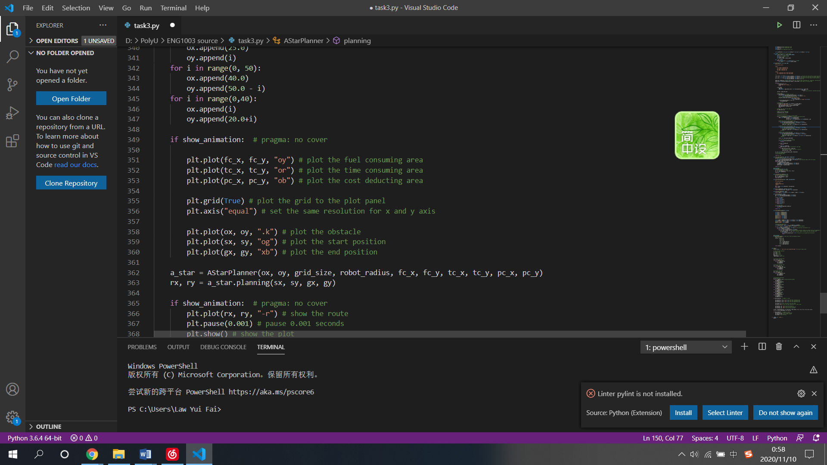

Finally, we add two input parameter pc_x and pc_y into the class AstarPlanner and call the function to execute.

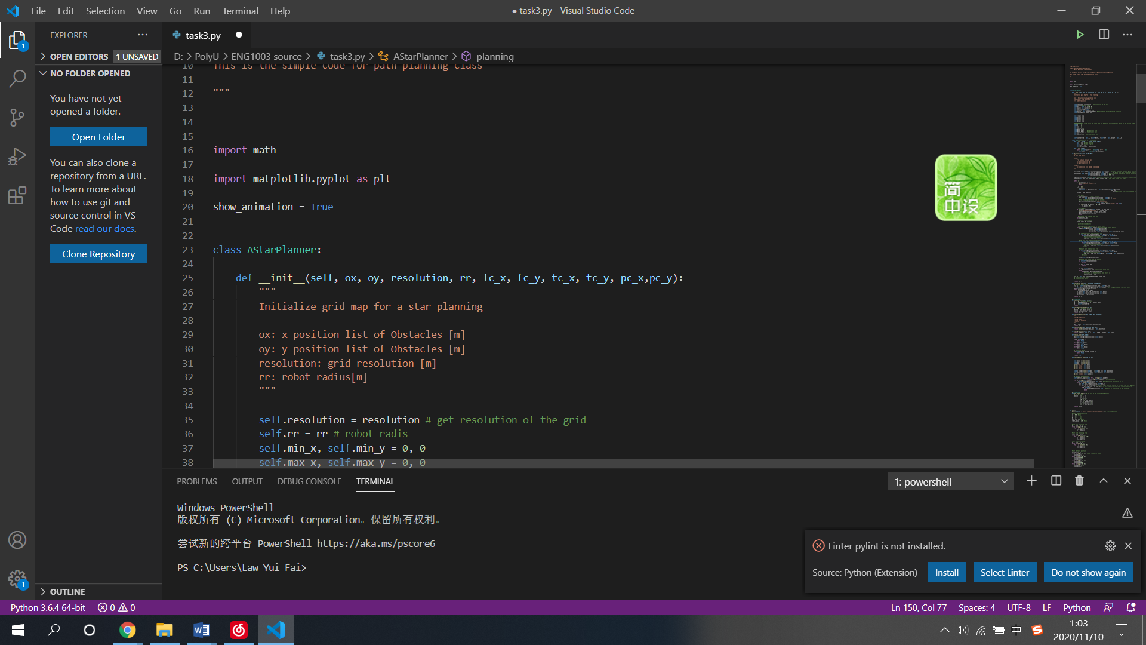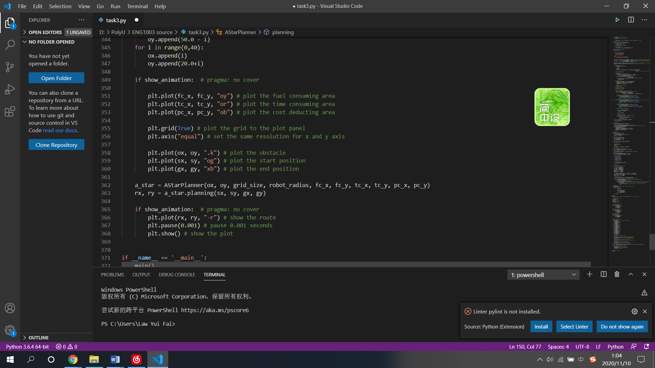

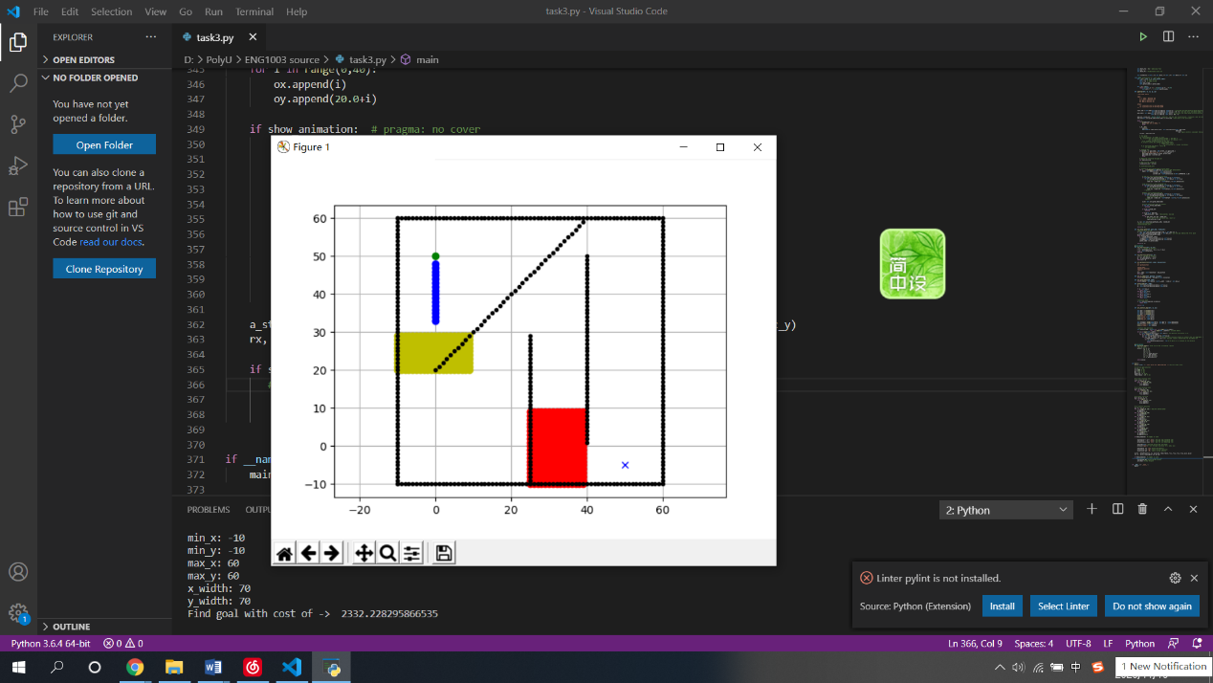The plotted graph will be shown like the right-hand side figure.

* 1. 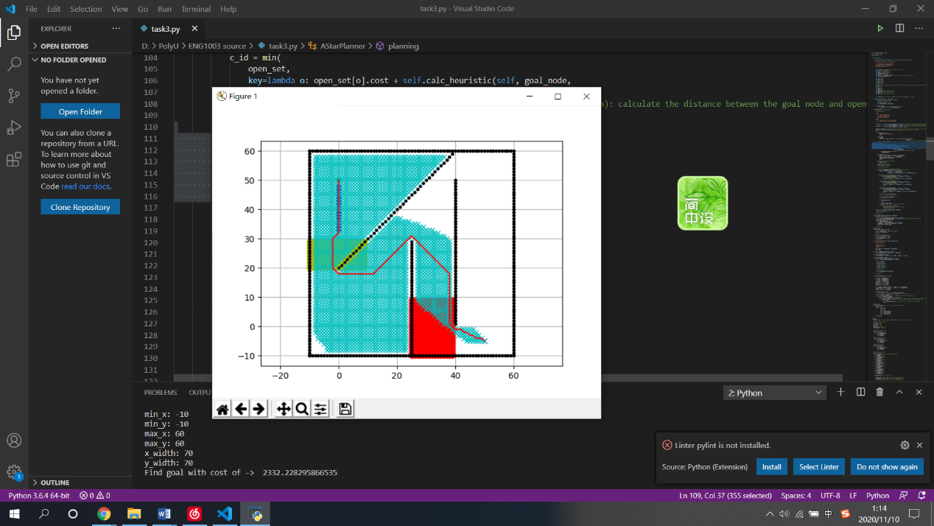Results

The route of task 3 in our group challenge is shown in the figure. After computing the cost from the python file, it gives a cost of 2332.228295866535.

* 1. Discussion

|  |  |  |
| --- | --- | --- |
| Model / Cost in | Task 1 | Task 3 |
| PolyU-A380 | 2396.228295866535 | 2332.228295866535 |

With the aid of the minus-cost area in task 3, the cost in task 3 for the same aircraft model is reduced by 64 units. The result satisfies our assumption in the planning state.

1. Reflective Essay (no more than one-page for each member)
   1. Member 1 (Bangyan FU)

When writing this report, I am still excited about all the new things this course brought. Although I am not the student from AE department, I chose this course because I’ve always been passionate about aviation. This class brought me into contact with the aviation industry from the academic level for the first time. It also exposed me to computer programming for the first time and laid a foundation for my future study.

For me, these several weeks of study were just like a long journey with plenty of problems to solve. Honestly I did met some difficulties which even trobled me for weeks, like the github settings and the VS Code. As a freshman with no experience on computer and coding, I had to spend time researching and understanding the knowledge by myself. With the help of Dr.Wen and my group mates, I eventually handled these problems and made my contribution to the group. By the way, I was strongly impressed by Github because of its strong function of online group collaborate. This online method is becoming more and more significant nowadays.

There is no doubt that path planning is of great importance to modern aviation industry. As the airspace is becoming more and more crowded, it makes every flight safer, and of course, more efficiently.

At last, I must express my sincere gratitude to Dr.Tsu, Dr.Wen and all my group members. They all tried their best to offer me help. I am also very proud of my groupmates, who are all very brilliant learners, and also very cooperative. It is our joint efforts that can achieve such excellent results. I’m looking forward to cooperating with them again in the future!

* 1. Member 2 (Ho Lam LAW)

Although I have heard of flight path planning and learnt about some basic knowledge about it, but I have never heard of using code to design a path planning. To be honest, I am weak at computer, I even felt quite scared when I learn that I need to use python and do coding. I have learnt a lot in this project, as my part is to report what out path planning algorithm is I have done more research on A* algorithm and it really intrigued me that how this concept is applied is computer games and in robot, it also inspires me to find more about coding stuff things that about AI, how they develop. Of course, one of the most important things that I have learnt is that self-learning is vital, as nowadays we can acquire any knowledge on the internet. We have learnt a lot from the internet, forums to know more about how to do the coding and inspire us to do the task.

Another thing that I have learnt is that since this is the first project that I have done in University, I need to learn to pick up things quicker. In addition, I know that I need to put more work in the project. As I have said, I am not good at computer, coding. Yet, I need to strengthen my skills in this subject as I believe there will be more project that is related to computer. Also I know that I need to communicate more with my groupmates, and enhance my working skills with my teammates.

* 1. Member 3 (Yui Fai LAW)

Regarding the content of the project, I can experience the works related to the aviation industry. For example, flight plan planning is an essential part of flights to make sure navigation aid is available and that is what we have learnt in these few weeks. During the hard-work on AAE freshman project, I have learnt the academic level of algorithm designs using python. A star path planning algorithm using python is a challenge for me as I learnt pascal instead of python in my secondary studies. I have to learn the syntax of python in a very short time to understand the code and lead my groupmates. Therefore, it is a good introduction to use python in my University studies.

Apart from the path planning algorithm, it is also a good chance to work on coding project remotely by using GitHub. It is the first time for me to use Github to collaborate with my groupmates online. As I am not familiarized with the Github system in desktop computer, I was trapped from the schedule in the first lecture. After few lectures, I recognized the advantages of Github. It provides code-sharing services to collaborate with different people. It will be helpful when more than one person is working on the project. Github also indicates the content of the updated codes to save the time of programmers. Therefore, Github is a famous platform for programmers all over the world to collaborate with their collaborators.

In the future, path planning will be a major topic in the aviation industry due to the rapid development of drones and AI. As integrity and safety are the utmost consideration in aviation industry, air traffic may face challenges in directing aircraft in crowded airspace in the city. As I am an AAE student, I am looking forward to participating in this field as I have a passion for aviation. Therefore, in these 4 years, I should work hard in accumulating my knowledge and expanding my views on aviation industry.

* 1. Member 4 (Chenyu WANG)

After learning the lecture --- DESIGN OF PATH PLANNING ALGORITHM FOR AIRCRAFT OPERATION, l find it is interesting, useful with quite a lot of difficulties for me. Actually, l didn’t good at programming at all, even l was unwilling to write some codes. But those innovative tasks really attracted me.

I finished all the tasks except task 3, those tasks take me a lot of time. I reviewed all the recordings over and over again. And finally, l understood most of what our professor wants us to learn.

To be frank, l am not a quick-learner like other group mates like Bangyan and Yui Fai, l could not work out the project in class. With the encouragement of my group members, l tried my best to figure out the principle and be familiar with those steps. I watched those recordings over and over again, sparing no effort to follow the schedule.

I also wrote e-mails to Dr.Wen and Dr.TSU to ask for help, thanks to their timely replies, l completed all the tasks except task3 after class, which gave me more confidence in learning this subject. Most important of all, l find l do not take unkindly to Programming.

I express my most sincere gratitude to Dr. TSU and Dr.Wen, Bangyan and Yui Fai

Thanks for offering me help.

Besides the progress in programming, l also learned something else. Before the outbreak of this novel virus, l only cooperated with my friend face - to - face for a project. But actually, cooperating online is more difficult than l thought before. After this, it will be less tough for me to handle the online teamwork.

Nowadays, computer is gradually playing a more and more important role in the aviation field. We have to make a more precise and comprehensive plan to help our plane. And that why we develop the technology of python.

* 1. Member 5 (Man Nok WONG)

In this project, not only do I know more about my new classmates and Aviation Engineering, but I also know more about myself in two ways.

Technically, I am encouraged to learn programming that I have never thought of. In this project, We are required to use GitHub and Visual Studio to do coding to find the best route for the flight.

Interpersonally, I have met new friends from my department to students from the Mainland. I learned to collaborate and trust each other, as we have our strengths and weaknesses. The most unforgettable part of the project is that when we started to approach the problems in different ways together, I felt like we are in a team.

There are several things that I would have improved next time. Firstly, Being more active even I am not interested in that topic. Staying active not only could help me understand the discussion better, but it also saves my groupmate's time.

Secondly, to be a self-learner. In this project, I had watched many YouTube videos about programming besides the tutorial. By watching more, I can learn more all-rounded and is much more efficient as I know what I am still confused by and thus I can focus and learn about those aspects.

1. References

[1] "Aviation Safety", Iata.org, 2020. [Online]. Available: https://www.iata.org/en/youandiata/travelers/aviation-safety/. [Accessed: 10- Nov- 2020].

[2] "Airline - Route Planning - Tutorialspoint", Tutorialspoint.com. [Online]. Available: https://www.tutorialspoint.com/aviation_management/aviation_management_airline_route_planning.htm. [Accessed: 10- Nov- 2020].

[3] Flightliteracy.com. [Online]. Available: https://www.flightliteracy.com/wp-content/uploads/2017/12/15-2.jpg. [Accessed: 10- Nov- 2020].

[4] "What are these VOR indicators telling you? GPS hasn’t completely supplanted VORs in instrument flying, so y… | Flight training, Aviation training, Aviation airplane", Pinterest. [Online]. Available: https://www.pinterest.com/pin/711779916083238194/. [Accessed: 10- Nov- 2020]. [5]"Gyroscopic Instruments (Part One) Attitude and Heading Indicators", Flight Literacy. [Online]. Available: https://www.flightliteracy.com/gyroscopic-instruments-part-one-attitude-and-heading-indicators/. [Accessed: 10- Nov- 2020].

[6]"Flight Management System (FMS) - The Aircraft's Brain! - Pilotstories", Pilotstories, 2017. [Online]. Available: https://pilotstories.net/flight-management-system-fms-aircrafts-brain/. [Accessed: 10- Nov- 2020].

[7]Hart, P. E.; Nilsson, N. J.; Raphael, B. (1968). "A Formal Basis for the Heuristic Determination of Minimum Cost Paths". P.100-107

[8] https://www.ics.uci.edu/~welling/teaching/ICS175winter12/A-starSearch.pdf